**Diagrams for each Use case**

1. Initial Pump Setup

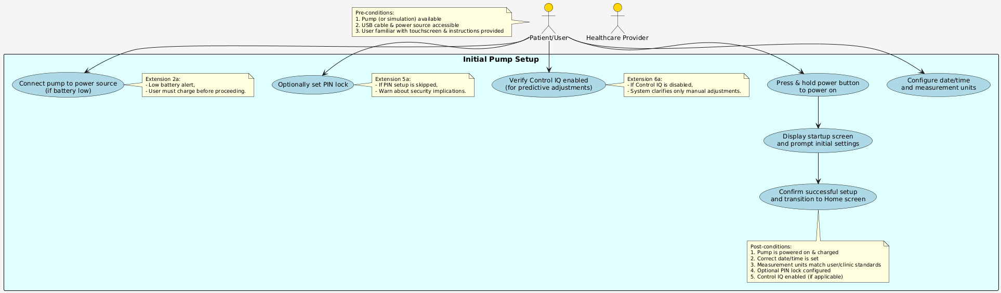

1. Manage Personal Profiles (CRUD)

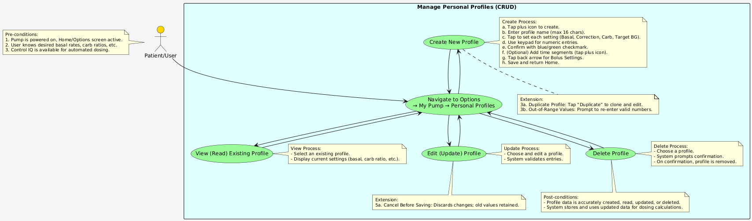

1. Deliver Manual Bolus (Including Extended Bolus)

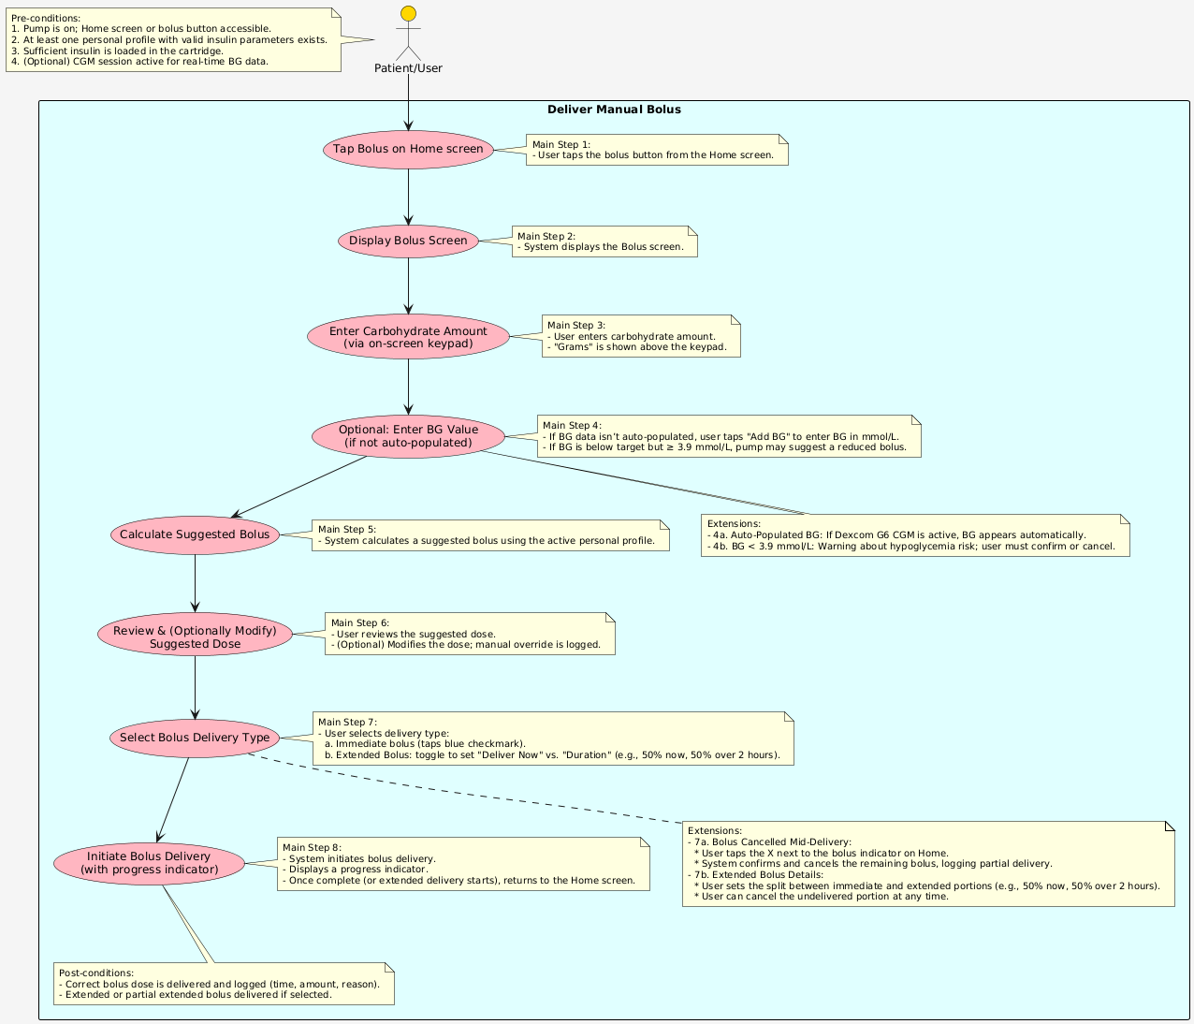

1. Start/Stop/Resume Basal Insulin Delivery (with Control IQ Automatic Adjustments)

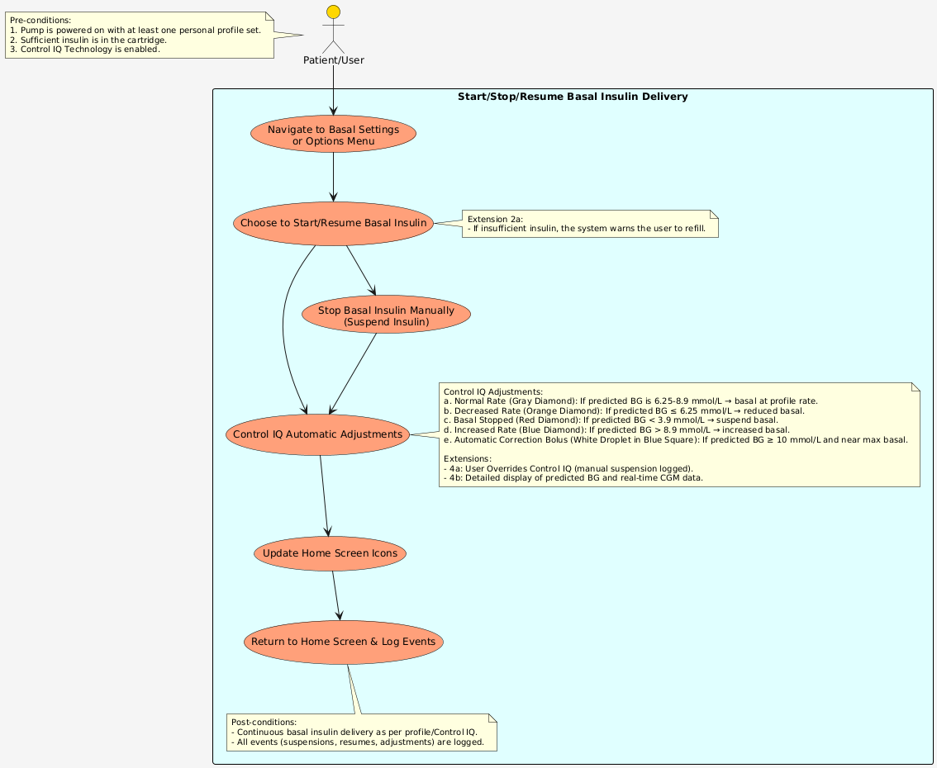

1. View Pump History and Data Visualization

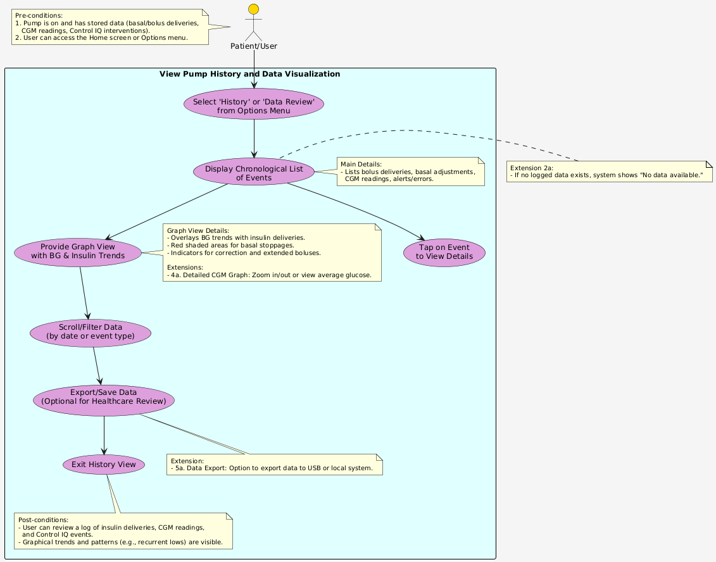

1. Handle Pump Malfunctions or Errors

